PRESS RELEASE – FOR IMMEDIATE RELEASE

After their daughter’s collapse, family urges all schools to Get Seizure Smart!

1 in 20 children will have a seizure by the time they are 15 years old and
1 in every 200 Australian school children will be diagnosed with epilepsy.

Six-year-old Millie was at her school athletics carnival when she was suddenly unable to speak. The then Year One student was crying and moving her arms around before collapsing to the ground unconscious. Confused, and thinking Millie had fainted, her teacher placed Millie on her back and elevated her legs, before the 000-operator advised to move her into the recovery position.

When terrified parents, Katie and Steve received the phone call advising that their daughter had collapsed, they rushed to be by her side in the emergency department. Speaking with doctors, mum Katie, recalled a similar incident 18 months earlier when, “Millie had been confused and dazed in class, and fallen over.” Further tests were ordered, and Millie was diagnosed with epilepsy.

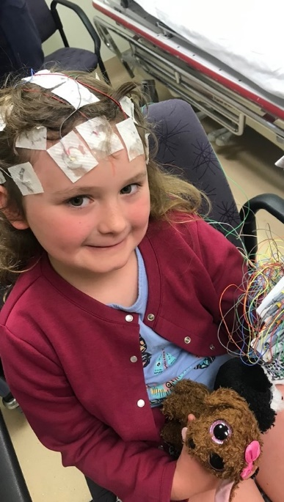
In shock, Katie recalls “we left ER with a very tired Millie and a pamphlet called ‘Your first seizure.” What followed was challenging for Millie and her family, who suddenly needed to advocate for their daughter to continue her education at the school. Katie explains, “it has been a disappointing and difficult path to navigate.”

It transpires that Millie had in fact, had multiple seizures in her early years of schooling which had gone unrecognised. “At a time when we needed support, our school was out of their depth on all thing’s epilepsy. We were left feeling isolated and an inconvenience.”

It is for this reason the Whapham family are urging all Australians and in particular, schools, to Get Seizure Smart. Their hope is that no family will live in fear.

Guidance from Epilepsy Queensland and the state school health nurse has now enabled Millie’s school to safely support her in the classroom. However, “we’ve been left crippled by fear and distrust,” says Katie. “If Millie’s seizures at school had been managed differently and staff had a basic understanding of what a seizure looked like, the result would have changed our lives.”

Epilepsy Queensland Chief Executive, Chris Dougherty says “seizures are more common than people realise. 1 in 20 children will have a seizure by the time they are 15 years old, being seizure smart is a critical skill for all Australians.”
Katie’s message is clear: “It should be a no-brainer. Learn seizure first aid and how to be seizure smart. Your actions will minimise the trauma on children and their families.”

About Get Seizure Smart
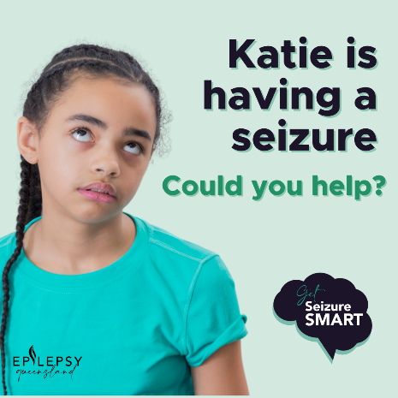
The Get Seizure Smart campaign asks the question – could you help a child if they had a seizure? Recognising the signs of a seizure and knowing how to respond with correct seizure first aid will help protect children from injury and could even save their life!
Epilepsy Queensland has been supporting Queenslanders to live well with epilepsy for over 50 years and this September their Get Seizure Smart Campaign teaches people to recognise and respond to seizures. “The signs of a seizure can be missed” explains Epilepsy Educator, Jenny Ritchie. “They are not always the shaking convulsions that people often associate with epilepsy. Signs of a seizure also include subtle eye movements, changes in cognitive ability, falling to the ground or other unusual behaviours.”
When you recognise that someone is having a seizure, the next step to being Seizure Smart is to administer correct seizure first aid and know when to call 000.
Step one - Time the seizure! A seizure becomes a medical emergency and requires an ambulance if it lasts longer than 5 minutes. However, if it is the first time a child has experienced a seizure, you should seek medical assistance. Stay calm and protect the child from injury. “This could mean moving things like hot drinks or furniture and protecting the child’s head with something small and soft,” instructs Jenny Ritchie, who has been teaching seizure first aid to Queenslanders for almost 15 years. “If their awareness is impaired, for example, they are confused or perhaps wandering, it may mean guiding them away from danger, such as a busy road.”
Visit the Epilepsy Queensland website to Get Seizure Smart, download the free Seizure First Aid and Recognising Signs of a Seizure posters for home, work or school. https://bit.ly/GetSeizureSmart
Not all seizures require emergency medical attention, but they can be life threatening; almost every day an Australian life is lost due to epilepsy.
- ends –
Talent available:
Epilepsy Queensland - Chief Executive Chris Dougherty, Epilepsy Educator Jenny Ritchie
Family story: Katie and Millie Whapham (images supplied: Katie Whapham)
MEDIA: For more information or media enquiries, please contact Epilepsy Queensland on (07) 3435 5000 or 0431 471 446
Shannon Bullen – Awareness and Engagement Specialist
sbullen@epilepsyqueensland.com.au

ABOUT EPILEPSY QUEENSLAND
For over 50 years, Epilepsy Queensland has been delivering help and hope to people impacted by epilepsy. We support individuals to live well by providing education and support for people living with epilepsy, their family, and carers.
We create a Queensland that is aware of epilepsy and its impacts on daily life, a Queensland that is seizure smart, who can recognise the signs of a seizure and who respond to seizures with appropriate first aid.
ABOUT SEIZURES & EPILEPSY
- Epilepsy is one of the most common neurological disorders, with around 65 million people globally living with the condition. Alarmingly, neurological disorders are the world’s leading cause of disability and the world’s second leading cause of death.
- Epilepsy is a medical condition that affects the brain and causes seizures, 1 in 10 Australians will experience a seizure.
- 1 in 20 or 5% of Aussie kids will have a seizure before the age of 15
- A quarter of a million Australians live with epilepsy and 30% of them are unable to control seizures with medication.
- 50% of people that have one seizure will go on to have more seizures in their lifetime
- Seizures occur due to a change in electrical activity in the brain
- Signs of a seizure vary depending on where in the brain the electrical activity occurs.
- Signs of a seizure can include a blank stare, unusual movements, muscle spasms or convulsions.
- 280 Australians are diagnosed with epilepsy each week. An epilepsy diagnosis is made when a person has unprovoked and recurring seizures.
- 1 in every 200 Australian school children will be diagnosed with epilepsy
- There are more than 70 different types of seizures and 40 epilepsy syndromes.
- Most seizures will last between a few seconds to a few minutes
- A seizure that lasts over 5 minutes is a medical emergency. Call 000
- Call 000 if a person’s breathing is affected post seizure, if they are pregnant, the seizure has occurred in water, if it is the person’s first seizure or they have more than one seizure, known as a ‘cluster’.

------------------ END---------------------
In 2018–19, there were 31,400 hospitalisations and more than 20,600 emergency department presentations associated with e

