**Gold Coast – beautiful one day, purple the next!**

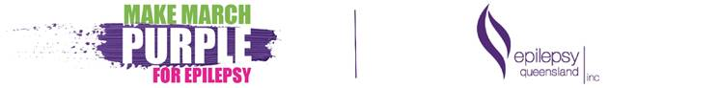

The blue skies have returned, and the **Gold Coast** will go purple this weekend in support of [‘**Make March Purple for Epilepsy’**](https://myimpact.epilepsyqueensland.com.au/make-march-purple), Epilepsy Queensland’s annual campaign to raise awareness and funds for those in our community living with epilepsy.

From the purple muck challenges, to purple cocktails and buildings – the Gold Coast has [Epilepsy Queensland](http://www.epilepsyqueensland.com.au) covered!

Making March Purple for Epilepsy is [Paradise Resort at Surfers Paradise](https://paradiseresort.com.au/) where barman, Tim Flemming and the team will show off their mixology skills creating cocktails so purple they put Barney the Dinosaur to shame.

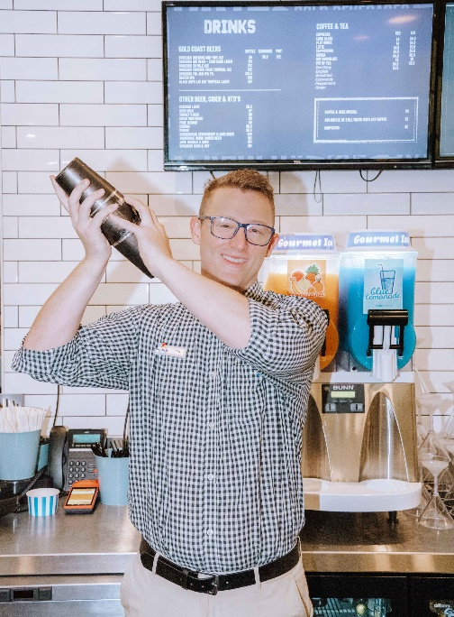 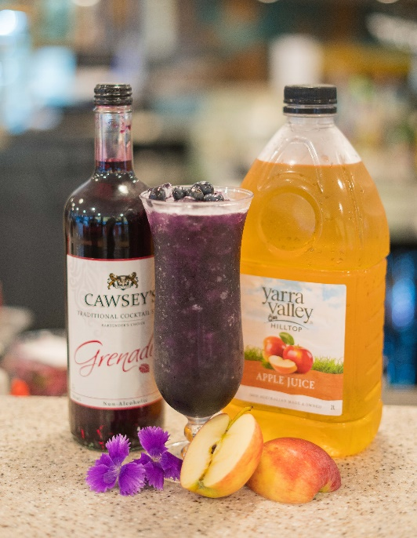

***Image:*** *Tim Flemming, Purple Gum Drop mocktail*

Tim has had epilepsy for most of his life- first diagnosed at age 8- and has managed his epilepsy with medication since. Recently, Tim’s niece, age 3, was also diagnosed with epilepsy.

Knowing the struggles associated with epilepsy first-hand, Tim is thrilled to raise awareness this weekend by serving up special cocktails and mocktails to the punters at the Poolside Bar at Paradise Resort.

“I’ve had epilepsy my whole life and know the struggles, so hopefully through this effort the team and I can make someone else’s life a bit easier,” Tim said.

Voted Australia’s Favourite Family Resort 10 years in a row – Paradise Resort will this weekend offer you a real **purple time!**

From **Friday 26 March through to Sunday 28 March**, all profits raised from the **Purple Martini,** the **Purple Sling,** and **for the kids – the Purple Gum Drop** will go to Epilepsy Queensland.

**WHEN:** Friday 26 March – Sunday 28 March

**WHERE:** Poolside Bar at Paradise Resort, Ferny Avenue, Surfers Paradise

Take a selfie with your drink at the Poolside Bar, post it, and tag **@epilepsyqueensland** and **#MakeMarchPurpleForEpilepsy**!

Once you have finished poolside, why not continue the purple theme into the evening by checking out ‘the illumination’ at Pacific Fair Shopping Centre.

**‘Illuminate and Celebrate’ – Pacific Fair Shopping Centre**

Pacific Fair Shopping Centre at Broadbeach will get in on the purple action joining other major building and icons from across the state to [‘Illuminate and Celebrate’](https://myimpact.epilepsyqueensland.com.au/make-march-purple/celebration-illuminations).

The team at Pacific Fair are thrilled to turn the centre purple to gain awareness for Purple Day with Epilepsy Queensland. Recognising the importance of the day, the team invite the Gold Coast to see the purple lights and participate in this day for the community.

**WHEN:** Friday 26 March – 6pm – 11pm

**WHERE:** Pacific Fair Shopping Centre @ Hooker Boulevard, Broadbeach

Take your selfie at Pacific Fair, post it, and tag **@epilepsyqueensland** and **#MakeMarchPurpleForEpilepsy**!

**MEDIA:** If you would like further information, or are interested in organising an interview of photo opportunity, please contact Epilepsy Queensland’s Communications Manager, Karen Furnivall on 07 3435 5000 / 0402 578 954 / [kfurnivall@epilepsyqueensland.com.au](mailto:kfurnivall@epilepsyqueensland.com.au).

For over 50 years, Epilepsy Queensland (EQI) has been the beacon of hope for people living wit, and impacted by epilepsy in Queensland. EQI is the only Queensland based epilepsy consumer support organisation and service provider. We provide psychosocial supports and counselling at all stages of a diagnoses, information and referral, education and training, and policy.