17 March 2022
Media Release: For immediate release
Every 33 minutes an Australian life is turned upside down by an epilepsy diagnosis.
You can help turn things around by supporting Epilepsy Queensland’s Make March Purple campaign this epilepsy awareness month.
WHAT: Make March Purple is an Australia-wide campaign supported by epilepsy organisations across the country and the national peak body – Epilepsy Australia.
WHEN: March 1- 31st 2022, including Purple Day March 26, International Day of Epilepsy Awareness
WHY: To raise awareness and share information about one of the world’s most common serious neurological conditions – epilepsy. Find more information HERE.
Globally, more than 65 million people live with the epilepsy and in Queensland 30,000
people are currently living with this diagnosis. Epilepsy is a neurological condition that causes
unpredictable seizures that suddenly interrupt a person’s daily life.

Every 33 minutes an Aussie will have their life turned upside down by an epilepsy diagnosis and, in
that moment, Epilepsy Queensland are there with understanding, information, and support to help
turn things around. Each year we answer more than 4000 calls for help.

Chief Executive of Epilepsy Queensland, Chris Dougherty says the funds raised during March contribute towards free education and workshops to help families understand and manage epilepsy.

“Working with someone to recognise what might trigger their seizures and what they can do to
manage their condition is important work. We have been working in the community for over 50 years to help people live well with epilepsy,” says Chris Dougherty.

“We deliver thousands of free training workshops to families all over Queensland, giving carers the skills and confidence to administer rescue medication that can be lifesaving. We also provide psychosocial support to help people cope with what can be a very challenging diagnosis.”

“The people we support want us to raise awareness of the impact that epilepsy has on their
everyday life. They want us to help everyone to understand that epilepsy is not just seizures, it
interrupts their employment, education, and relationships.”

When you get involved in Make March Purple you help turn things around for children and families with epilepsy. Your support means kids with epilepsy can go to school safely because we have trained staff to understand and manage the condition. By Making March Purple you keep kids safe at home, because we can teach parents seizure first aid and how to administer lifesaving medication.

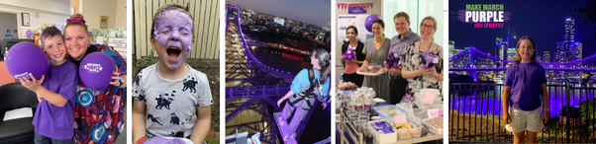
How can you help turn things around and Make March Purple?
Raise funds:
- Host an event at work, school, or home. Click here to register
- Take on the ultimate challenge and join the #BRAVE team who will climb the story bridge as it lights up purple. Click to learn more
Raise awareness:
- Turn things around by posting an upside-down photo to social media click for more information
- Visit and photograph one of more than 55 Queensland landmarks that will light up PURPLE

To support Make March Purple visit: https://bit.ly/MakeMarchPurple
For information about epilepsy visit our website: epilepsyqueensland.com.au.

MEDIA OPPORTUNITIES: Filming and photo opportunities – local epilepsy community members, illuminated landmarks
Radio: 30 sec Make March Purple CSA, Live interviews, “Ask an epilepsy educator”
Talent/interviews: Epilepsy ‘local heroes’, fundraisers hosting events and activities, Epilepsy Queensland CEO and Epilepsy Educators.
Graphic Design Assets available here
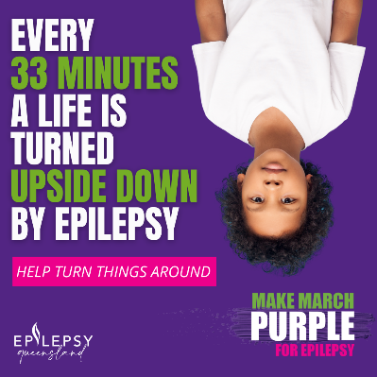
If you would like further information or are interested in setting up an interview or photo opportunity, please contact:

Melissa Simpson
Manager, Partnerships and Engagement, msimpson@epilepsyqueensland.com.au
Phone: 0479 178 281

Shannon Bullen
Specialist, Awareness and Engagement, sbullen@epilepsyqueensland.com.au
Phone: 0431 471 446

ABOUT EPILEPSY

Epilepsy is a medical condition that affects the brain and causes recurring seizures.
Epilepsy is the most common serious neurological condition in the world.
Seizures occur when the brain’s nerve cells (neurons) misfire and generate sudden,
uncontrolled bursts of electrical activity in the brain.
Signs of a seizure vary depending on where in the brain the electricity occurs
Children under 5 years and adults over 60 years are the most common groups
to be diagnosed with epilepsy, however.
Epilepsy can affect ANYONE, at any age or stage of life.
50% of people do not know the cause of their epilepsy
30% of people with epilepsy will not respond to medication and seizures will remain uncontrolled.

For more than 50 years, Epilepsy Queensland has delivered help and hope to people and
families impacted by epilepsy. Each year, we answer nearly 4000 calls to
our Epilepsy Helpline and we deliver over 2000 community education
sessions. We advocate for the 30,000 Queenslanders living with the condition and we are the organisation that 3000 newly diagnosed Queenslanders turn to each year for help, understanding, and information.

- END -

