24 February 2022
Media Release: For immediate release

Gladstone will help to turn things around this March
Gladstone will be glowing in a wash of purple from the 21st – 27th of March, when it joins more than 100 countries around the world who will light up their key landmarks purple, to show support for people living with epilepsy.
Globally, more than 65 million people live with the condition and here in Queensland 30,000 people are currently diagnosed with epilepsy. Epilepsy is a neurological condition that causes unpredictable seizures that suddenly interrupt a person’s education, employment, and daily life.
For the first time, venues across Gladstone are gearing up for the Epilepsy Queensland campaign to Make March Purple. Structures lighting up include the Old Pilot Wharf, the upstream side of the Matthew Finders Bridge, the Entrance to East Shores, the Base of Auckland Hill, the Water park in East Shores, and the end of Spinnaker Park.
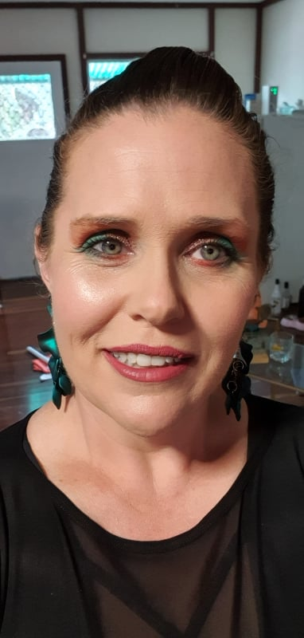
“We cannot thank Gladstone Regional Council enough,” says Epilepsy Queensland’s Chief Executive, Chris Dougherty. “Every 33 minutes an Aussie will have their life turned upside down by an epilepsy diagnosis and, in that moment, we are there with understanding, information, and support to help turn things around.”
That moment came for Gladstone local, Kay Guascoine, when she was aged 28 years old. Kay was working as a teacher and “fainted,” hitting her head on the side of a desk as she fell to the ground. She was flown to Rockhampton for an MRI and later attended the RBWH in Brisbane, where neurologist Dr Tho confirmed a diagnosis of epilepsy.
“Finding out that I have epilepsy was both a burden and a blessing at the same time,” says Kay. “Dr Tho was able to explain to me that my inability to concentrate for long periods of time and my lack of short-term memory were all because of my epilepsy. Suddenly, not being able to remember things like my times tables throughout school suddenly made sense!”

“However, I didn’t know anyone else with epilepsy,” she continues. “I didn’t know how much it would impact on my career, on my life – and I didn’t realise just how little is known about epilepsy in the wider community.”
Kay, now 40, finds comfort and connection via Epilepsy Queensland’s online community. “It’s nice to be able to chat with other people who have the same condition- people who understand what it’s like. It’s just nice to know I am not alone!”
Kay is excited that her town is getting behind the Make March Purple campaign to bring greater awareness to epilepsy. “Epilepsy is a complex condition. It’s not just the stereotypical ‘fall on the floor’ seizures that you’ve seen or heard about.” Kay is also keen to use her professional and personal experiences to educate others. “I would dearly love to be able to work with schools to make more teachers aware of epilepsy and how it affects children’s education and confidence” she says.
It could not be easier for everyone in Gladstone to help turn things around for people with epilepsy. Simply post any photo to your social media – upside down! Rotate any photo and post it to any social media platform with the caption “I am helping to turn things around for people with epilepsy”. By challenging and tagging friends you will spread the awareness even further! Use the hashtags #MakeMarchPurple and @epilepsyqueensland. Who do you want to see turn things around?

WHAT: Gladstone landmarks light up PURPLE for epilepsy awareness
WHEN: Friday 21 – 27 March 2022
WHERE: Old pilot wharf, Matthew Finders Bridge, East Shores, Auckland Hill, East Shores water park, and Spinnaker Park.
WHY: To support Epilepsy Queensland’s Make March Purple Campaign and the 30,000 Queenslanders impacted by epilepsy
MEDIA OPPORTUNITES:
Filming and Photo opportunities in front of illuminated landmarks
Radio: 30 and 15 second Make March Purple CSA, Live interviews “Ask an epilepsy educator”
Talent/interviews: Kay Guascoine, e: jellybean211981@gmail.com ph: 0428681908 Local fundraisers hosting events and activities, Epilepsy Queensland CEO and Educators.
Graphic Design Assets available here
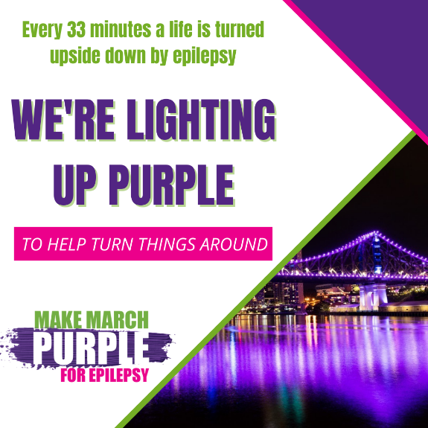

For more information and to arrange an interview please contact
Epilepsy Queensland; Melissa Simpson
Manager, Partnerships and Engagement, msimpson@epilepsyqueensland.com.au
Phone: 0479 178 281

-END -

