17 March 2022
Media Release – for Immediate Release
Local Pittsworth hero champions epilepsy awareness for sister with life-changing diagnosis
Chloe Bradford, 20, is not afraid to get her hands (and the rest of her) dirty for a good cause. The brave Pittsworth local is set to be slimed purple in support of people impacted by epilepsy, including her 16-year-old sister Bridie. Bridie lives with Dravet Syndrome, which is a rare, catastrophic form of epilepsy characterised by frequent and/or prolonged seizures.
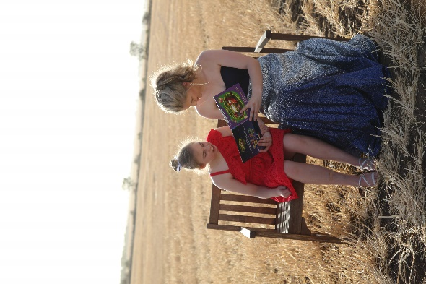
"This year for Epilepsy Queensland’s Make March Purple campaign, I am doing the purple muck challenge. If I reach my fundraising goal of $1000, I will be covering myself in purple slime,” explains Chloe. “It is extremely important to me to raise funds for Epilepsy Queensland to spread awareness for all the people living with epilepsy.”
Chloe, who was just four years old at the time, recalls Bridie’s first seizure vividly: “Bridie was just six months old and playing on her toy piano, and suddenly fell forward. When Mum went to pick her up, Bridie was blue around the lips and started convulsing. By the time the ambulance arrived her first seizure was over. Unknown to our family, that was the beginning of our new ‘normal’”.
Bridie was 12 years old by the time she finally received her epilepsy diagnosis after endless tests, medications and doctors’ visits. As is so often the case, epilepsy has had a profound impact on the entire family.
“When my younger brothers and I finally reached an age where we understood what this diagnosis means for Bridie, it was one of the hardest things – knowing we have a full, normal life, and Bridie never will. Living with epilepsy is a crazy challenge day in day out, sleepless nights and crap days. Dad and Mum are the two strongest people I know and manage her epilepsy and the daily challenge so well,” says Chloe.
“Epilepsy Queensland made an enormous difference, especially at the start of Bridie’s journey -showing my parents that they are not alone or isolated in this journey. There are plenty of people going through similar experiences to talk to.”
Chris Dougherty, Epilepsy Queensland Chief Executive says, “the funds raised during March help us to provide free education and workshops to families like Chloe’s. We help them to understand epilepsy and give carers the skills and confidence to administer rescue medication - which can be lifesaving. The psychosocial support we provide to people like Chloe’s family is critical to helping them cope.”

Understanding this all too well, Chloe is determined to help raise funds and awareness to help others. However, she wants the wider public to think twice before judging a book by its cover. “Epilepsy does not define a person. Not much fazes Bridie, except being told ‘no’,” laughs Chloe. “She loves being outside on a motorbike or golf buggy, going to see the cattle and stirring up her brothers.”

Show your support for Chloe’s purple muck challenge and donate here: https://myimpact.epilepsyqueensland.com.au/fundraiser/ChloeBradford/purple-muck-for-epilepsy

WHAT: Make March Purple is an Australia-wide campaign supported by epilepsy organisations across the country and the national peak body – Epilepsy Australia.
WHEN: The Make March Purple Campaign runs from March 1- 31st 2022. World Purple Day occurs on 26 March, 2022.
WHY: To raise awareness and start conversations about one of the world’s most common serious neurological conditions – epilepsy. Find more information HERE.
WHO: Globally 65 million people live with epilepsy. In Australia, every 33 minutes a person receives a life-changing epilepsy diagnosis. In Queensland 30,000 people and their families are impacted.
To support Make March Purple visit: https://bit.ly/MakeMarchPurple
END

MEDIA: Interview and/or photo opportunities available, please contact:

Melissa Simpson
Manager, Partnerships and Engagement, msimpson@epilepsyqueensland.com.au
Phone: 0479 178 281

Shannon Bullen
Specialist, Awareness and Engagement, sbullen@epilepsyqueensland.com.au
Phone: 0431 471 446

ABOUT EPILEPSY

Epilepsy is a medical condition that affects the brain and causes recurring seizures.
Epilepsy is the most common serious neurological condition in the world.
Seizures occur when the brain’s nerve cells (neurons) misfire and generate sudden,
uncontrolled bursts of electrical activity in the brain.
Signs of a seizure vary depending on where in the brain the electricity occurs
Children under 5 years and adults over 60 years are the most common groups
to be diagnosed with epilepsy, however.
Epilepsy can affect ANYONE, at any age or stage of life.
50% of people do not know the cause of their epilepsy
30% of people with epilepsy will not respond to medication and seizures will remain uncontrolled.

ABOUT EPILEPSY QUEENSLAND

For more than 50 years, Epilepsy Queensland has delivered help and hope to people and
families impacted by epilepsy. Each year, we answer nearly 4000 calls to
our Epilepsy Helpline and we deliver over 2000 community education sessions. We advocate for the 30,000 Queenslanders living with the condition and we are the organisation that 3000 newly diagnosed Queenslanders turn to each year for help, understanding, and information.
For information visit our website: epilepsyqueensland.com.au.

