21 March 2022
Media Release – for Immediate Release
Brave Stanthorpe teen sets her sights high to raise epilepsy awareness
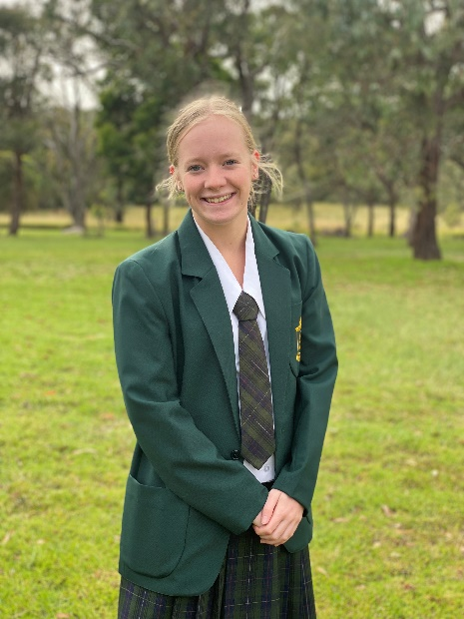
On Friday March 25, Sixteen-year-old Kiara Osborne is set to climb to the top of the Story Bridge, just as it lights up PURPLE!
Each March, landmarks around the world turn purple in support of people impacted by epilepsy. Kiara has signed up to the Epilepsy Queensland Story Bridge Climb challenge after being diagnosed with epilepsy last year. The event is part of the national Make March Purple campaign.
“In April 2021, I had my first seizure. It came as a real shock to my family. It was extremely out of the blue, we were unsure of what was causing my seizures or what to expect,” Kiara recalls. “Every time I’ve spoken to someone at Epilepsy Queensland, they offered help and have been a great support to us. They helped me understand what epilepsy is, as I didn’t really know much about it.”
Kiara was formally diagnosed with epilepsy in July 2021 and was prescribed anti-seizure medication. Like many people, Kiara had to trial multiple medications to help control her seizures. “The medication worked for a few weeks, but we were disappointed when I had more seizures. After some inconclusive tests, I was prescribed a different medication for night-times seizures which thankfully has worked better”
Despite still adjusting to the challenges of epilepsy, Kiara remains positive and wants to help raise funds and awareness to help others. “Before my seizures, I had no idea how many people are sadly diagnosed with epilepsy each week. Whilst my story has a good outcome, for many people it doesn’t. Around half of people diagnosed struggle to find the reason for their seizures. I not only want to raise funds to help those who are struggling but to also raise awareness and how people can help,” says Kiara.

Kiara is now 6 months seizure free and will join a team of 30 people, including Deputy Premier, the Hon Dr Steven Miles, other Members of Parliament and radio presenters to take on the Story Bridge climb challenge. Thanks to the Stanthorpe community and her family and friends Kiara been able to raise over $2500 in less than a month. “I have also gotten my school, St Joseph’s, involved in Make March Purple and we are having an Epilepsy Awareness Day at the end of Term 1.” Says Kiara.

Chris Dougherty, Epilepsy Queensland Chief Executive says, “the funds raised during March help us to provide free education and workshops to families like Kiara’s. We help them to understand their epilepsy and give carers the skills and confidence to administer rescue medication - which can be lifesaving. The psychosocial support we provide to people like Kiara, when they are first diagnosed is critical to helping them cope.”

Show your support for Kiara’s purple bridge climb and donate here: Kiara Osborne (epilepsyqueensland.com.au)

WHAT: Make March Purple is an Australia-wide campaign supported by epilepsy organisations across the country and the national peak body – Epilepsy Australia. The Story Bridge climb is an Epilepsy Queensland event that will see 30 people scale to the top of the bridge just as it lights up purple for epilepsy awareness.
WHEN: The Story Bridge climb takes place of Friday March 25th from 4pm. Make March Purple Campaign runs from March 1- 31st 2022,
WHY: To raise awareness and start conversations about one of the world’s most common serious neurological conditions – epilepsy. Find more information HERE.
WHO: Globally 65 million people live with epilepsy. In Australia, every 33 minutes a person receives a life-changing epilepsy diagnosis. In Queensland 30,000 people and their families are impacted.
To support Make March Purple visit: https://bit.ly/MakeMarchPurple
END

MEDIA: Interview and/or photo opportunities available, please contact:

Melissa Simpson
Manager, Partnerships and Engagement, msimpson@epilepsyqueensland.com.au
Phone: 0479 178 281

Shannon Bullen
Specialist, Awareness and Engagement, sbullen@epilepsyqueensland.com.au
Phone: 0431 471 446

ABOUT EPILEPSY

Epilepsy is a medical condition that affects the brain and causes recurring seizures.
Epilepsy is the most common serious neurological condition in the world.
Seizures occur when the brain’s nerve cells (neurons) misfire and generate sudden,
uncontrolled bursts of electrical activity in the brain.
Signs of a seizure vary depending on where in the brain the electricity occurs
Children under 5 years and adults over 60 years are the most common groups
to be diagnosed with epilepsy, however.
Epilepsy can affect ANYONE, at any age or stage of life.
50% of people do not know the cause of their epilepsy
30% of people with epilepsy will not respond to medication and seizures will remain uncontrolled.

About Epilepsy
For more than 50 years, Epilepsy Queensland has delivered help and hope to people and
families impacted by epilepsy. Each year, we answer nearly 4000 calls to
our Epilepsy Helpline and we deliver over 2000 community education sessions. We advocate for the 30,000 Queenslanders living with the condition and we are the organisation that 3000 newly diagnosed Queenslanders turn to each year for help, understanding, and information.
For information visit our website: epilepsyqueensland.com.au.

